DDoS Mitigation System using eBPF and ML model

I. INTRODUCTION:
The rapid growth of the Internet has established it as a fundamental pillar of modern society, driving economic growth, facilitating global communication, and enabling critical digital services. However, this increased dependency introduces significant vulnerabilities, particularly from Distributed Denial-of-Service (DDoS) attacks, which have evolved into pervasive threats to online service availability and reliability. Modern DDoS attacks attempt to overwhelm servers, services, or networks with excessive traffic, rendering them unavailable to legitimate users. [1]
The trend indicates that attackers are now using more advanced and persistent methods to exploit vulnerabilities on a large scale.[3] The Microsoft 2022 DDoS attack report highlights that the United States, India, and East Asia were among the most frequently targeted regions, collectively accounting for more than 70% of global incidents. These observations underscore the widespread and transnational impact of DDoS threats, posing risks to both advanced and developing digital infrastructures [4].
Regularly monitoring some specific network traffic metrics has become the fundamental approach to achieve this goal: for instance, a sharp rise in the number of source IPs contacting a particular destination IP can be an indicator of an in-progress DDoS attack [5]. To mitigate the impact of such volumetric attacks on other parts of the network, attack detection systems deployed on network devices (or middleware) at the network edge have been proposed as first-line of defense. While edge based systems can provide network-wide detection, the latter is mainly concerned with filtering malicious traffic before it reaches internal systems. When it comes to threats within an edge-cloud computing environment, such as lateral movement attacks [5], edge-based solutions show their limitations
To also mitigate DDoS caused by internal threats, host based detection solutions are very promising. Host machines such as servers in data centers have a user space and a kernel space. While user space is the area where user applications and processes run, kernel space is a lower-level area where the core of the operating system executes: classical host-based solutions are deployed as applications in the user space, but such methods experience latency as the network traffic has to first go through the kernel space and then be forwarded to the detection application in the user space for inspection. Recent advancements in the operational capability of Linux kernels by means of the extended Berkeley Packet Filtering (eBPF) technology have provided new possibilities. By ex ploiting kernel-space solutions such as the aforementioned eBPF and the related eXpress Data Path (XDP) [5], high performance packet processing and monitoring tasks can be moved from user to kernel space. This type of offloading can enable an early inspection of network traffic by avoiding the necessity to forward it from kernel to user space.
DoS and DDoS attacks, which pose significant challenges for organizations that rely on network services. On the other side, researchers also address the need for timely and accurate responses to such attacks. To develop an IDS that captures and analyzes network traffic efficiently to detect and respond to security threats in real-time, this research will use the eBPF as well as machine learning algorithms such as Random Forest, Support Vector Machine. [7]
The main focus of this paper is to guarantee an efficient and a real-time DDoS mitigation system that combines lightweight machine learning models with eBPF/XDP-based packet filtering to achieve intelligent, high-speed threat detection and mitigation. The system operates at the kernel level using Extended Berkeley Packet Filter (eBPF) and eXpress Data Path (XDP) for ultra-fast packet processing, while employing a Random Forest classifier trained on the CIC-DDoS-2019 dataset for accurate attack classification.

2.Literature
Authors / Year | Title / Work | Contribution to the Research Community / Society | Identified Drawbacks | How the Proposed Work Addresses the Gap
H. Chen et al. (2023) | Network Situation Awareness Technology based on eBPF | Introduced an eBPF-based framework for real-time network situational awareness, enabling efficient traffic monitoring and early visibility of abnormal patterns at kernel level. | Focuses mainly on monitoring and visualization; lacks active mitigation and intelligent attack classification mechanisms. | Extends situational awareness by integrating real-time mitigation using XDP and intelligent classification of DDoS attacks.
Y. Zhang et al. (2025) | Efficient Packet Filter Technology Based on eBPF | Demonstrated high-performance packet filtering using eBPF, significantly reducing processing overhead compared to traditional firewalls. | Rule-based filtering requires predefined rules and cannot adapt dynamically to unknown attack patterns. | Combines fast kernel-level filtering with adaptive statistical baselines and learning-based detection.
K. Živanović & P. Vuletić (2025) | Kernel-Level DDoS Protection Using eBPF in IoT Networks | Proposed a lightweight kernel-level DDoS defense suitable for resource-constrained IoT environments. | Limited to IoT-specific protocols and static threshold-based detection. | Generalizes the approach to multi-protocol environments and supports adaptive detection for varying traffic patterns.
S. Remya et al. (2025) | eBPF-Based Runtime Detection of Semantic DDoS in Containers | Addressed semantic DDoS attacks in containerized environments using eBPF for runtime monitoring. | Focused only on container platforms; mitigation response is limited and environment-specific. | Provides a unified architecture applicable to cloud, enterprise, and containerized systems with active mitigation.
M. Zang et al. (2025) | In-Kernel Traffic Sketching for Volumetric DDoS Detection | Proposed in-kernel traffic sketching techniques for efficient volumetric DDoS detection at line rate. | Primarily targets volumetric attacks; lacks detailed attack-type classification. | Enhances detection by integrating ML-based multi-vector attack classification.
A. Hirsi et al. (2025) | DDoS Anomaly Detection in Software-Defined Networks | Provided a comprehensive study of statistical and anomaly-based DDoS detection techniques in SDN environments. | SDN controller-based detection introduces latency and scalability concerns. | Moves detection closer to the data plane using eBPF/XDP to reduce response time.
N. Anand et al. (2025) | eBPF and Machine Learning-Based Intrusion Detection | Combined eBPF with machine learning to improve intrusion detection accuracy. | Machine learning operates entirely in user space, leading to delayed mitigation. | Proposes a hybrid architecture where filtering occurs at kernel level while ML assists in decision making.
A. Sadiq et al. (2023) | DoS Detection in Kubernetes using eBPF | Applied eBPF for detecting DoS attacks in Kubernetes-based cloud systems. | Detection-centric approach with limited automated mitigation strategies. | Incorporates automated response and adaptive mitigation policies.
H. J. Hadi et al. (2024) | iKern: Kernel-Level IDS/IPS Using eBPF | Designed an advanced kernel-level IDS/IPS capable of detecting multiple attack types. | High complexity and limited discussion on scalability under extreme traffic loads. | Focuses on scalable filtering and selective offloading to user space for analysis.

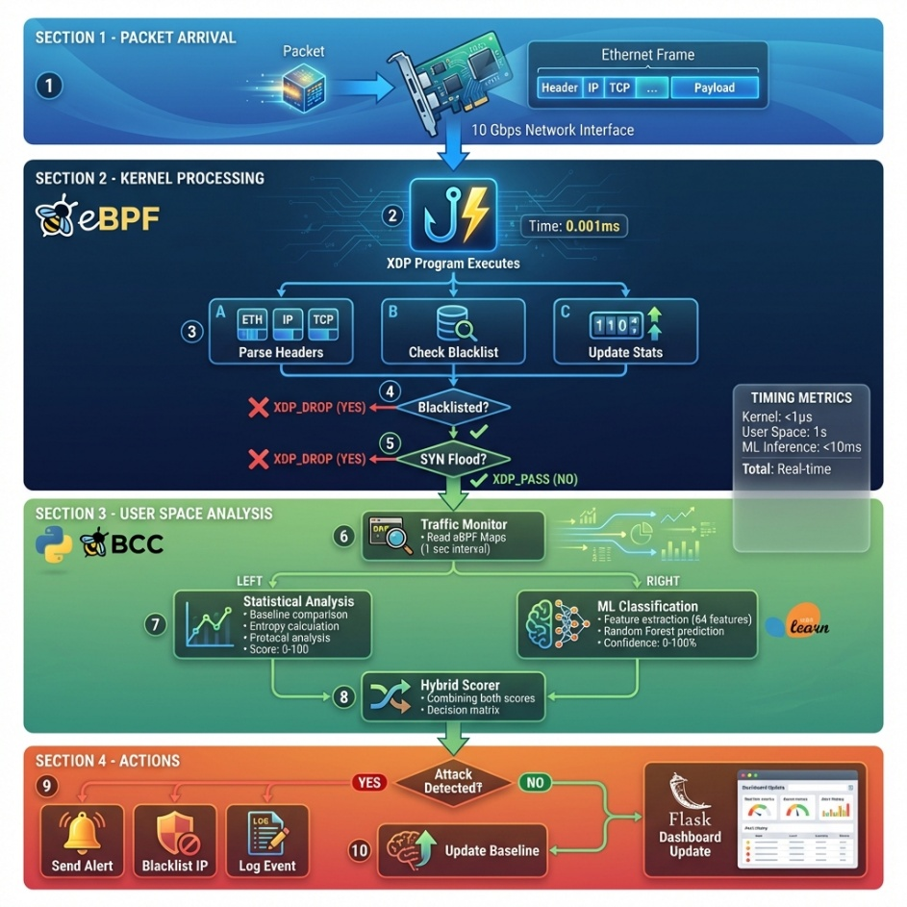

REFERENCES
[1] H. Chen, D. Song, Y. Zheng and F. Xiong, "Network Situation Awareness Technology based on Extended Berkeley Packet Filter," 2023 3rd International Conference on Electronic Information Engineering and Computer Science (EIECS), Changchun, China, 2023, pp. 101-104, doi: 10.1109/EIECS59936.2023.10435373
[2] Y. Zhang, H. Wang and P. Gao, "Research on Efficient Packet Filter Technology Based on eBPF," 2025 IEEE 8th Advanced Information Technology, Electronic and Automation Control Conference (IAEAC), Guiyang, China, 2025, pp. 891-894, doi: 10.1109/IAEAC65194.2025.11165810.
[3] K. Živanović and P. Vuletić, "Kernel-Level DDoS Protection Using eBPF in Iot Networks," 2025 33rd Telecommunications Forum (TELFOR), Belgrade, Serbia, 2025, pp. 1-4, doi: 10.1109/TELFOR67910.2025.11314317.
[4] S. Remya et al., "eBPF-Based Runtime Detection of Semantic DDoS Attacks in Linux Containers," in IEEE Access, vol. 13, pp. 169178-169219, 2025, doi: 10.1109/ACCESS.2025.3614389.
[5] M. Zang, F. De Iaco, J. Wu and M. Savi, "In-Kernel Traffic Sketching for Volumetric DDoS Detection," ICC 2025 - IEEE International Conference on Communications, Montreal, QC, Canada, 2025, pp. 2180-2185, doi: 10.1109/ICC52391.2025.11161251.
[6]A. Hirsi et al., "Comprehensive Analysis of DDoS Anomaly Detection in Software-Defined Networks," in IEEE Access, vol. 13, pp. 23013-23071, 2025, doi: 10.1109/ACCESS.2025.3535943.
[7 Anand, N., M A, S., Aakula, P.K., Ponnuru, R.B., Patan, R., Reddy, C.R.P.: Enhancing intrusion detection against denial of service and distributed denial of service attacks: Leveraging extended Berkeley packet filter and machine learning algorithms. IET Commun. 19, e12879 (2025). https://doi.org/10.1049/cmu2.12879

[8] Chang Liu, Byungchul Tak, and Long Wang. 2024. Understanding Performance of eBPF Maps. In Proceedings of the ACM SIGCOMM 2024 Workshop on eBPF and Kernel Extensions (eBPF '24). Association for Computing Machinery, New York, NY, USA, 9–15. https://doi.org/10.1145/3672197.3673430
[9] NEMALIKANTI ANAND, SAIFULLA M A, Pavan Kumar Aakula et al. High-performance Intrusion Detection Systemusing eBPF with Machine Learning algorithms, 05 July 2023, PREPRINT (Version 1) available at Research Square [https://doi.org/10.21203/rs.3.rs-3140072/v1]
[10] Sadiq, A., Syed, H. J., Ansari, A. A., Ibrahim, A. O., Alohaly, M., & Elsadig, M. (2023). Detection of Denial of Service Attack in Cloud Based Kubernetes Using eBPF. Applied Sciences, 13(8), 4700. https://doi.org/10.3390/app13084700
[11] Hadi, H. J., Adnan, M., Cao, Y., Hussain, F. B., Ahmad, N., Alshara, M. A., & Javed, Y. (2024). iKern: Advanced Intrusion Detection and Prevention at the Kernel Level Using eBPF. Technologies, 12(8), 122. https://doi.org/10.3390/technologies12080122

